Java Setup
Maven Setup
React + Nodejs Setup

Install Ubuntu Virtual machine on Windows via MS Azure Cloud
Install below on the VM
Docker
Docker Hub
Setting PAT between Docker and Docker Hub
Kubernetes
Kubectl
Minikube (for minikube minimum 2 vCpus are required when installing ubuntu VM)
(time stamp 26:49 , Kubernetes fundamentals: 25th to 26th April)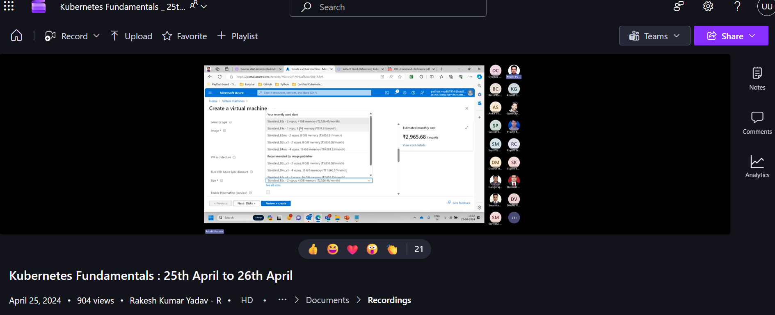
You Can login to VM via Putty
Azure Linux VM + Setting Up Jenkins on Linux VM
Terraform installation and setup, setting path and environment var
VS Code setup
prepare mail seeking to setup the above though i am in servicenow

